**Report**

Project Name: DongDong

Date: 29.4.2024 -19.4.2024

Group 7 Members:

Andy (Haoran) Du (540762259)

Kieran Huang (540313453)

Chen Yuan (540276963)

Zhouhan Wang (540310382)

Jianfeng Zhang (510030375)

Jiayuan Zhang (540237218)

**1. Introduction**

This report presents the final outcomes of our software development project, which has now successfully passed the first stage of development. Our client has requested the completion of the application within the next few weeks, along with a comprehensive user guide to facilitate staff training. The user guide is designed to ensure that anyone not involved in the application development can quickly get started with the software. The report will detail our development process, including our use of Jira for project management and GitHub for version control. We have rigorously tested our application to ensure its robustness and reliability before delivering the final product.

**2. Development Outcome**

1. Verification & Validation

#6 test cases based on the functions in our application

Test Case 1- Invalid login

Objective: Verify system response to incorrect login credentials.

Steps: Enter an invalid job number or password.

Expected result: Login fails with an error message.

Test Case 2- Register new employee

Objective: Make sure the registration process works for new employees.

Steps: Fill in the name, account number, set password and enter one’s department.

Expected results: The new employee registers successfully and then jumps back to the login interface.

Test Case 3- Access Sales Data Analysis

Objective: After logging in with the operation department account, confirm that sales data analysis is accessible and display the data.

Steps: Enter a valid item name and select "Customer Analysis".

Expected results: The sales data report is displayed.

Test case 4- Printing basic information of express shipment

Objective: Print basic information of the shipment

Steps: Login with transportation department account, and skip to warehouse page. Enter the product name, courier company, order time, and then click Print

Expected result: Display express order printed successfully

Test Case 5 - Inventory Inquiry

Objective: Correctly display current inventory quantity and current order quantity in the database

Steps: Enter product name and warehouse number, and then click Search.

Expected results: Display the current inventory and order quantity of the product

Test case 6- Download product information

Objective: Make sure the download functionality works with correct input.

Steps: Enter valid product name, vendor name, and transaction date, then click Download.

Expected results: Display the correct transaction data file is downloaded.

2. Guideline for the user

#E-Commerce Management Software User Manual

Contents:

1. System Requirements

2. Log-in and Registration

3. Main Interface Overview

4. Sales Data Analysis

5. Product Analysis

6. Marketing Effectiveness Evaluation

7. Customer Analysis

8. Product Information Query and Shipping Label Printing

9. Inventory and order information inquiry

10. System Settings and Support

11. FAQ (Frequently Asked Questions)

1. System Requirements

Ensure your computer or mobile device meets the following system requirements:

Operating System: Windows 10 or higher, Mac-OS 10.14 or higher

Memory: Minimum of 4GB RAM recommended

Storage: At least 1GB of free space

Network: Continuous internet connection required

2. Log-in and Registration

2.1 Log-in

1. Launch the software and you will be greeted by the log-in page.

2. Enter your operation job number in the “Operation job number” field.

3. Enter your password in the “Password” field.

4. To stay logged in for future sessions, check the “Keep me signed in” box.

5. Click the “Sign in” button to authenticate and proceed to the main interface.

2.2 Registration

1. On the log-in page, click the “New employee?” link to go to the registration page.

2. Fill in the following details:

Working Email: Used to receive verification emails and reset password links.

First Name and Last Name: Enter your given and family names respectively.

Set Password: Create a secure password for log-in.

Job Number: Provided by your department manager.

Verification: Enter the code received in your email.

3. Click “Start Working” to complete the registration and automatically return to the log-in page.

3. Main Interface Overview

Depending on your department, the system will display relevant data analysis options based on your log-in credentials. For example, “oper-001” will show options pertinent to the operations team.

The main interface centrally displays your profile information and quick access to department-specific functions.

4. Sales Data Analysis

1. Select “Sales Data Analysis” from the main menu.

2. In the prompted interface, choose or enter the product number and date range for analysis.

3. Click the “Search” button, and the system will generate a detailed sales report including charts and key metrics.

4. The report includes sales trends, revenue analysis, and customer preferences.

5. Product Analysis

1. Select “Product Analysis” from the menu.

2. Enter or select the series or type of product you wish to analyze.

3. The analysis results provided will include market performance, stock status, and sales recommendations.

6. Marketing Effectiveness Evaluation

1. Select “Marketing Effectiveness Evaluation”.

2. Input the identifier or name of the marketing campaign.

3. The system analyzes and provides a report on the campaign’s effectiveness, including ROI and customer engagement metrics.

7. Customer Analysis

1. Select “Customer Analysis”.

2. Enter the customer ID or related keywords to search.

3. The system will display the customer’s purchase history, preference analysis, and satisfaction assessments.

8. Product Information Query and Shipping Label Printing

1. Enter the product name, vendor name, and carrier name.

2. Click “confirm printing” to save or print the relevant shipping documents.

9. Inventory and order information inquiry

1. Use the drop-down menu to select or enter the keywords for product, you can query the current inventory and order quantity of this product.

2. Enter the vendor name and transaction date in the fields provided.

3. Click "Download" to retrieve data.

10. System Settings and Support

Navigate to “Settings” to adjust account information, permissions, etc.

For technical issues, contact support or consult the “Help” section.

11. FAQ

Provides guidance for common operational and technical questions.

**3. Team Collaboration**

1. Jira reports including Burnup Chart and Burndown Chart

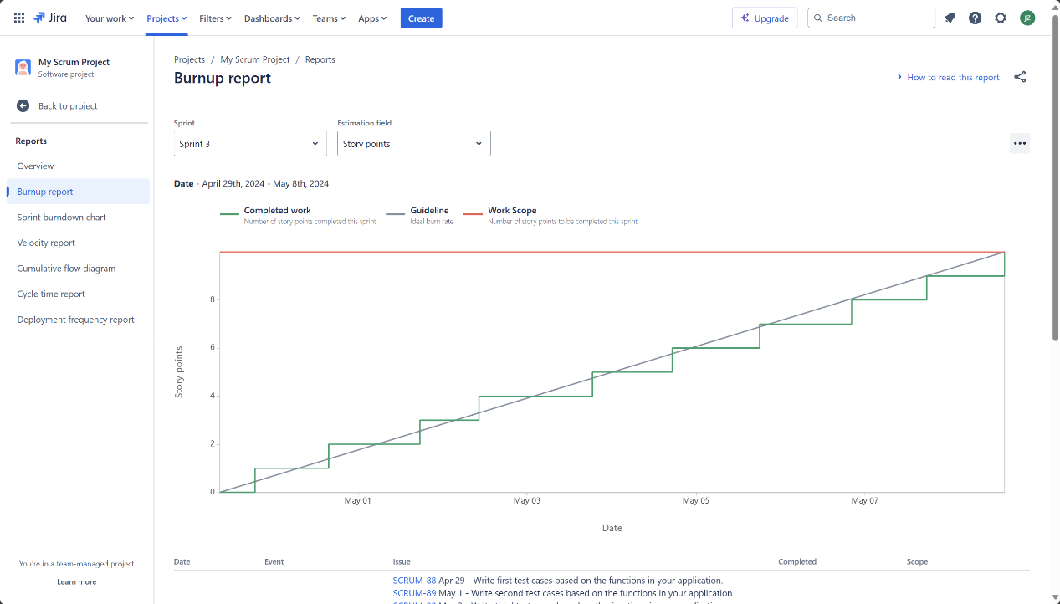

The sprint 3 burn-up chart ↑

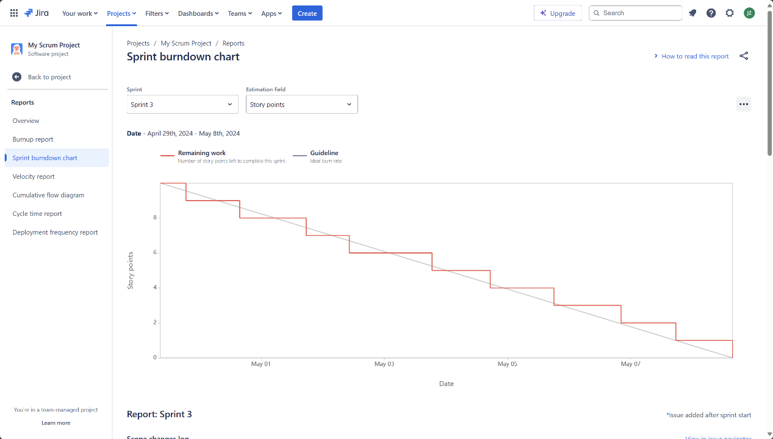

The sprint 3 burn-down chart ↑

2. GitHub commit record and history

**4. Test outcomes in PowerApps**

Screenshots of 6 test results

Test case 1:

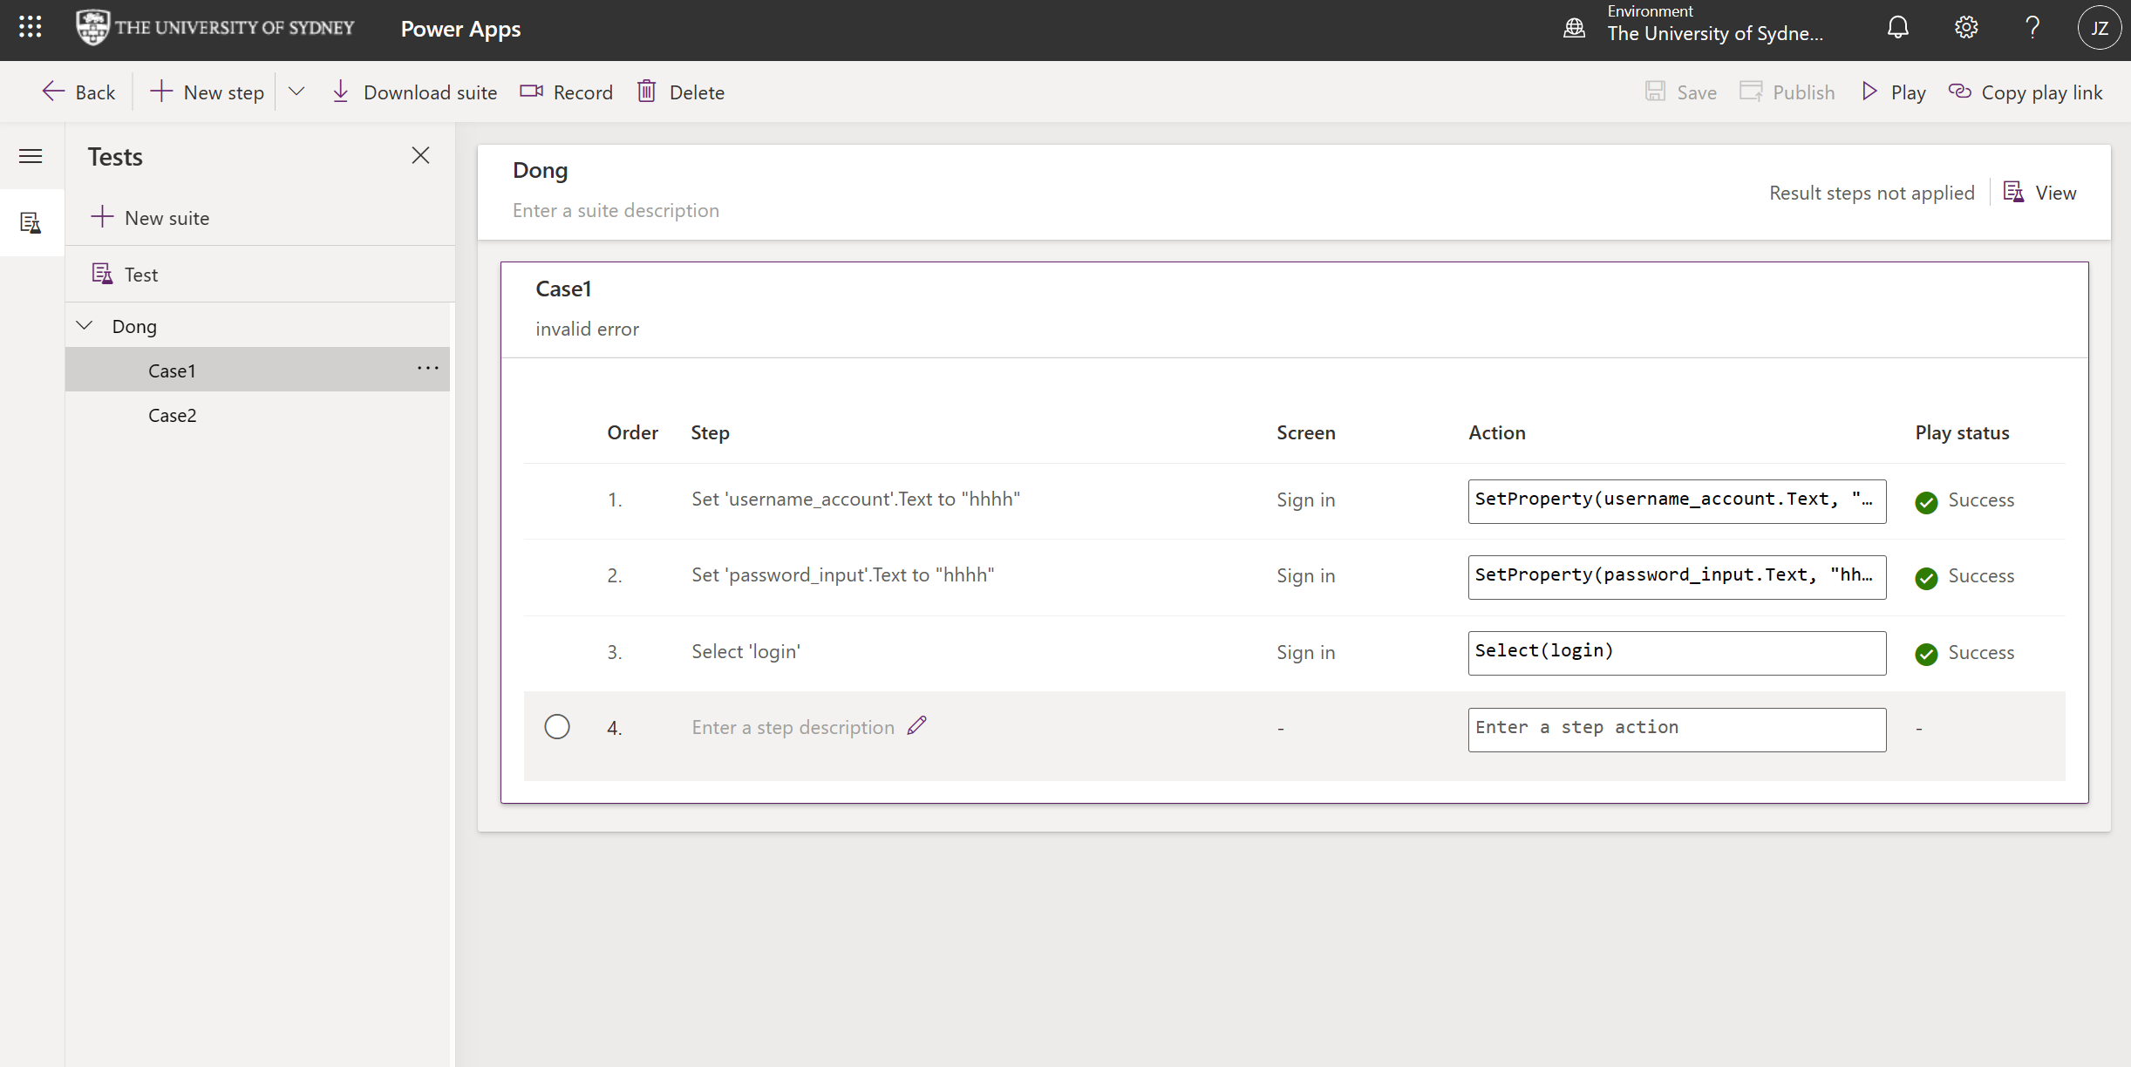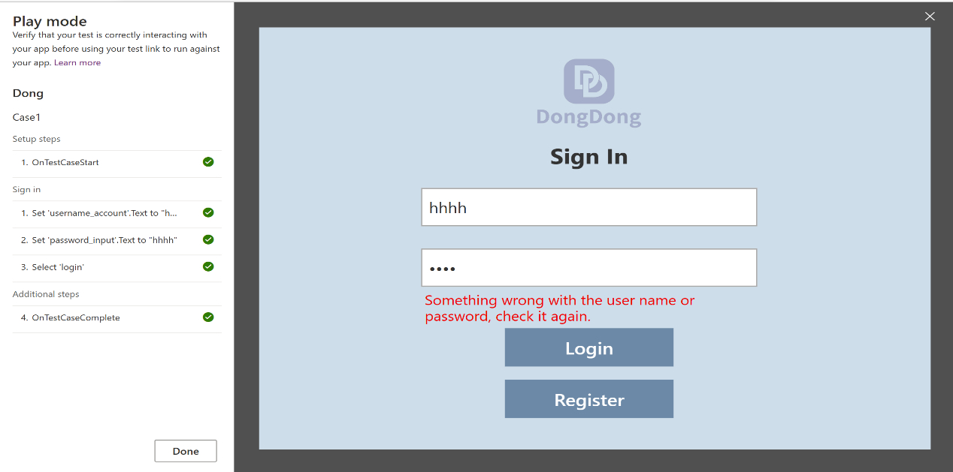

Test case2:

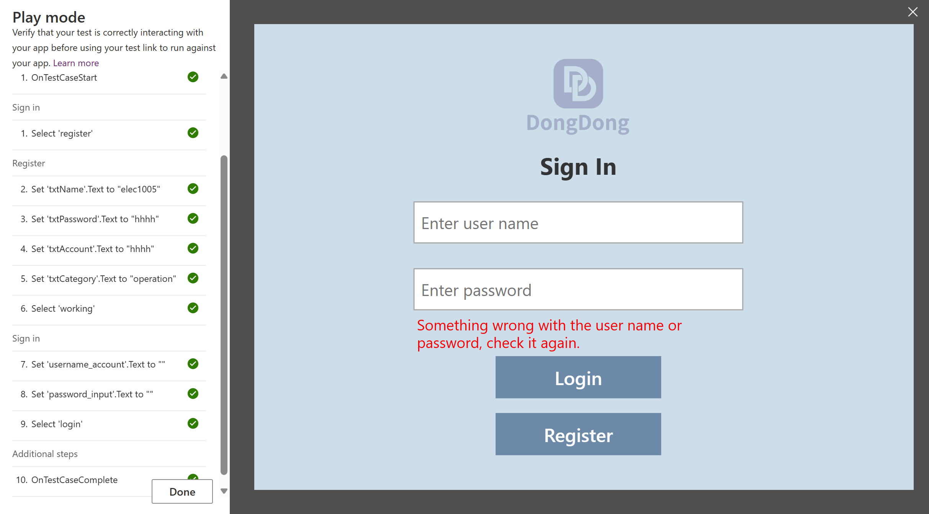

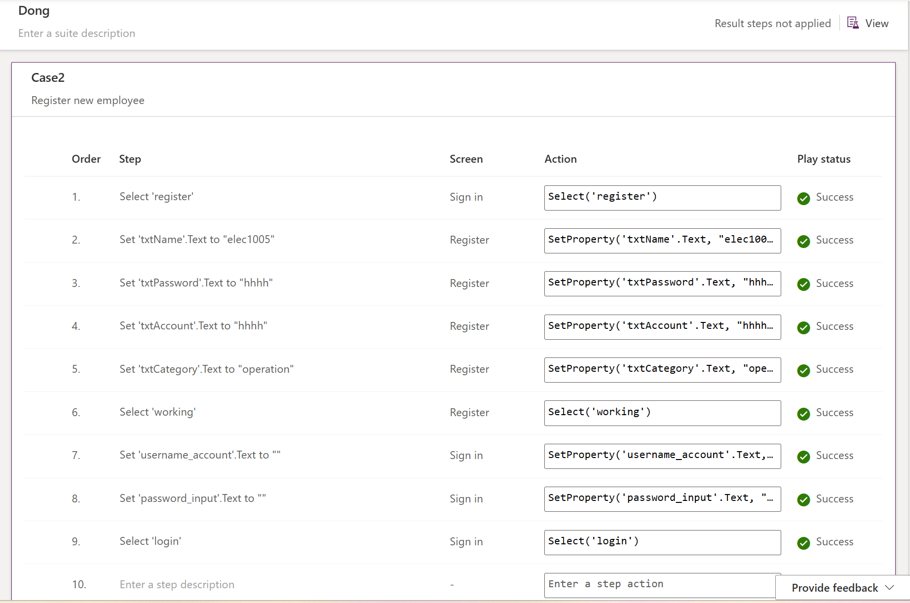

Test case3:

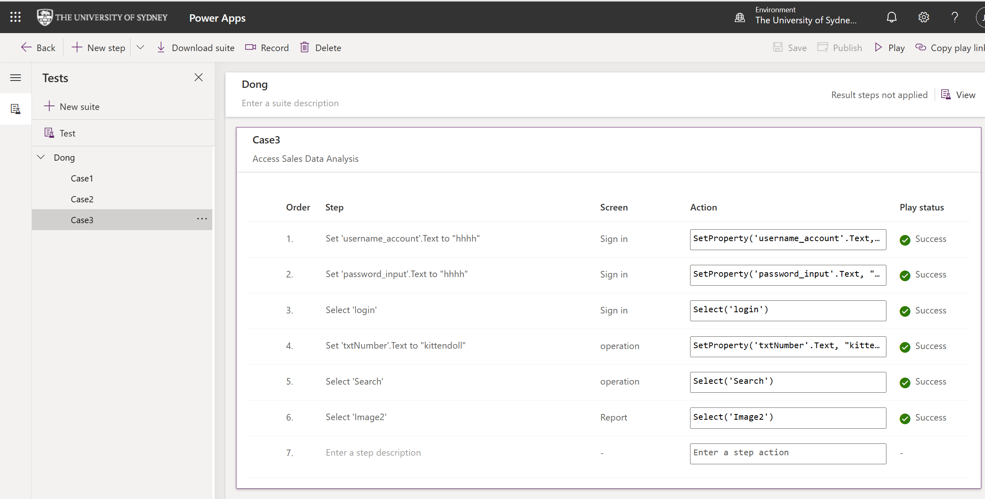

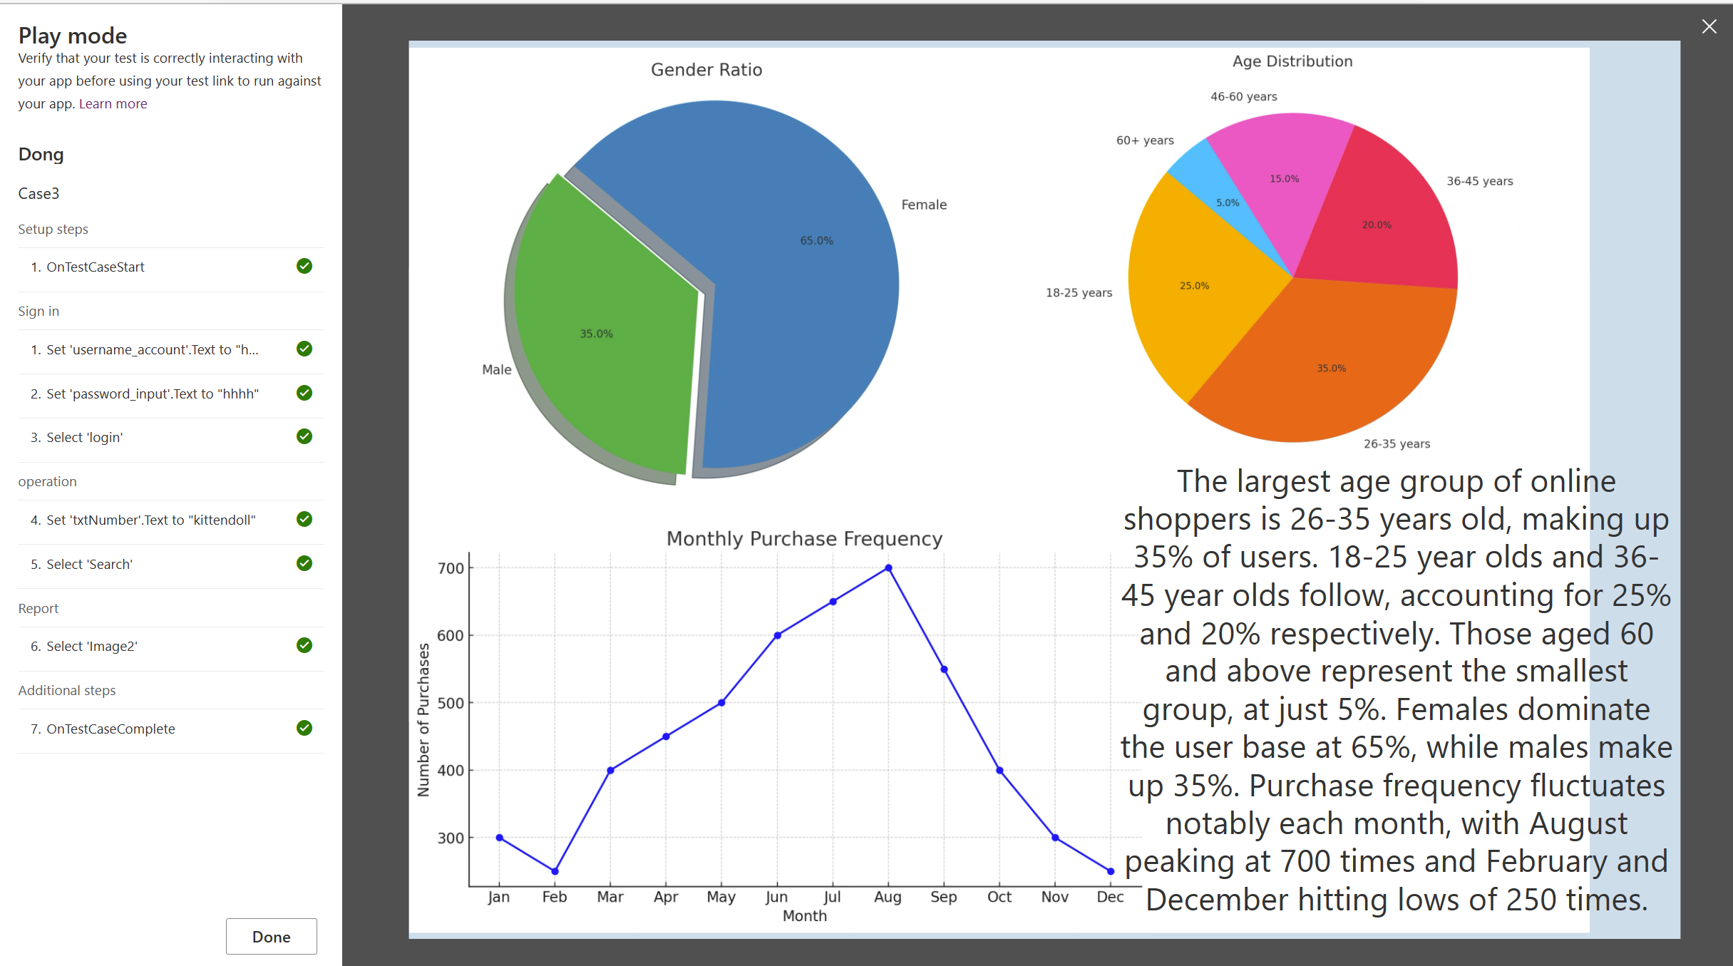

Test case4:

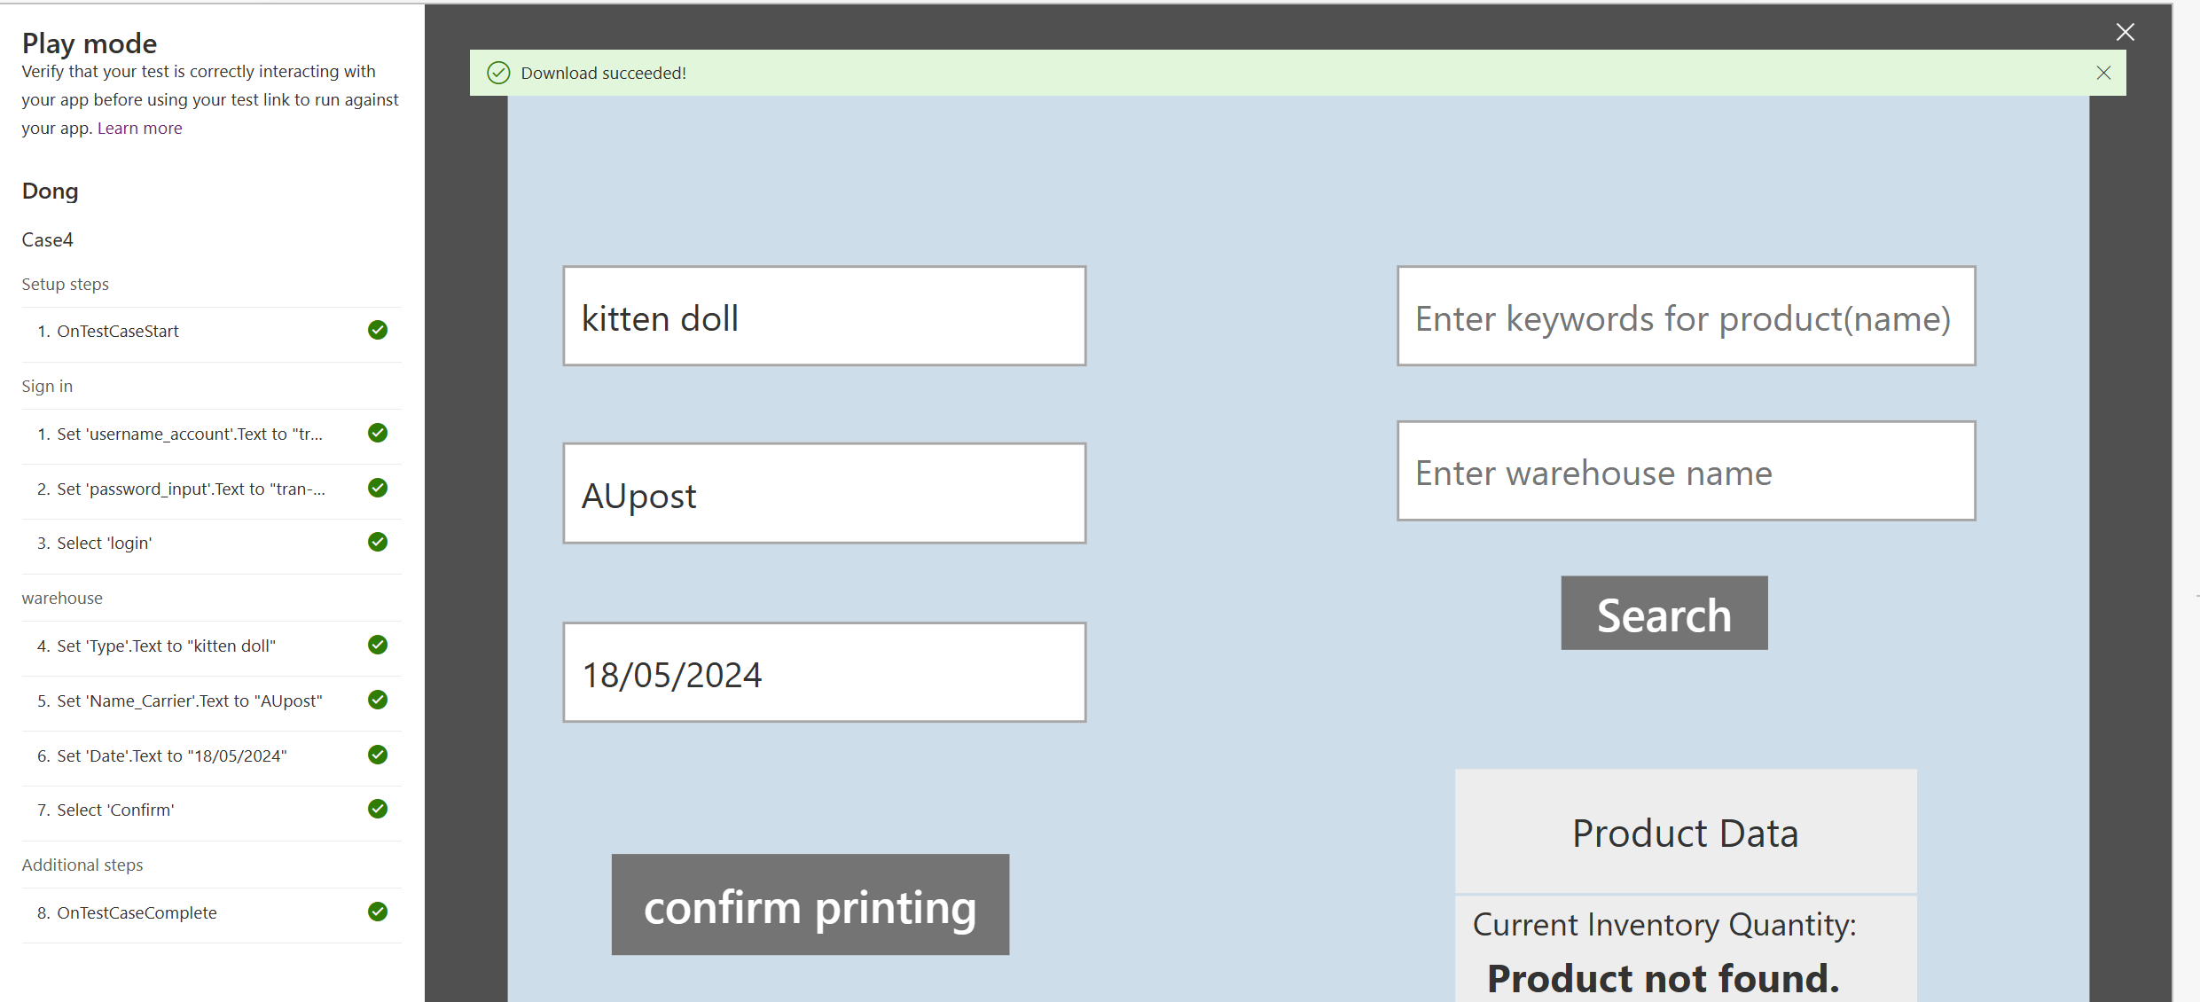

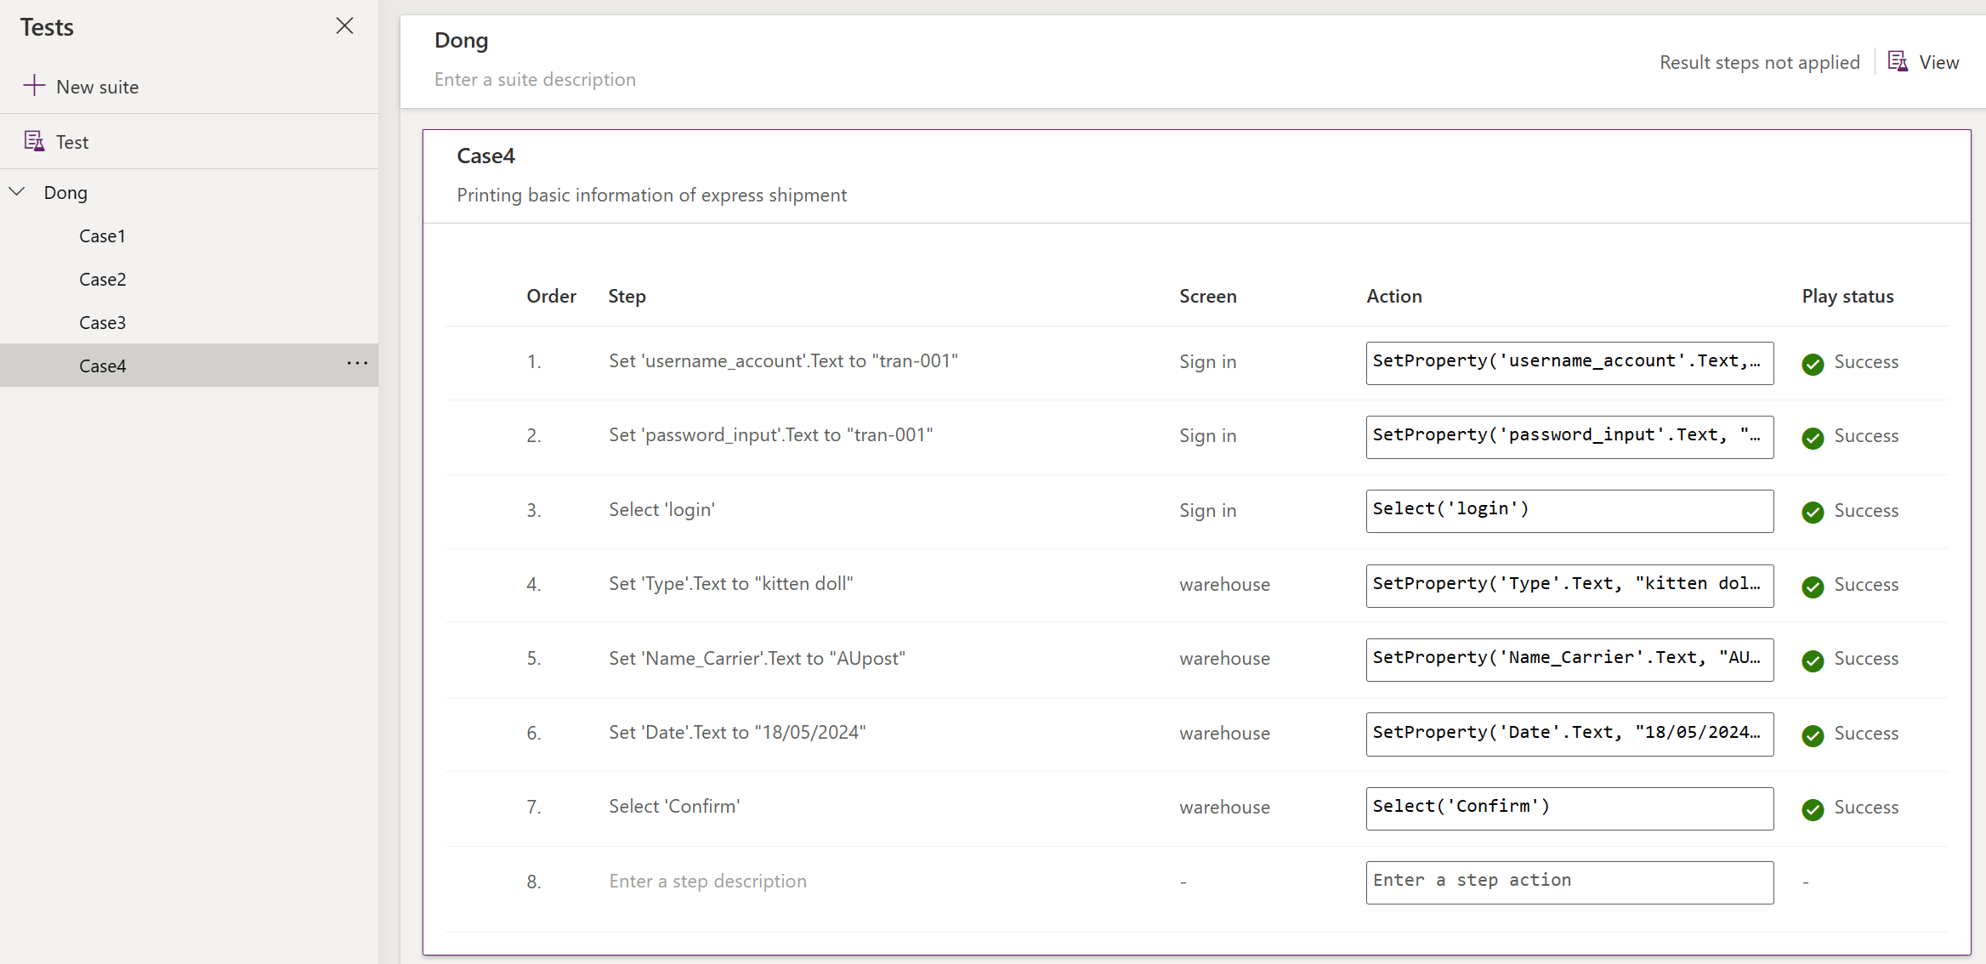

Test case5:

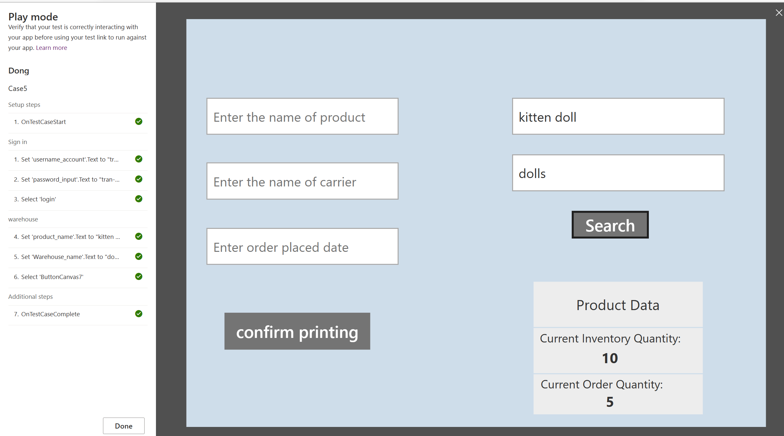

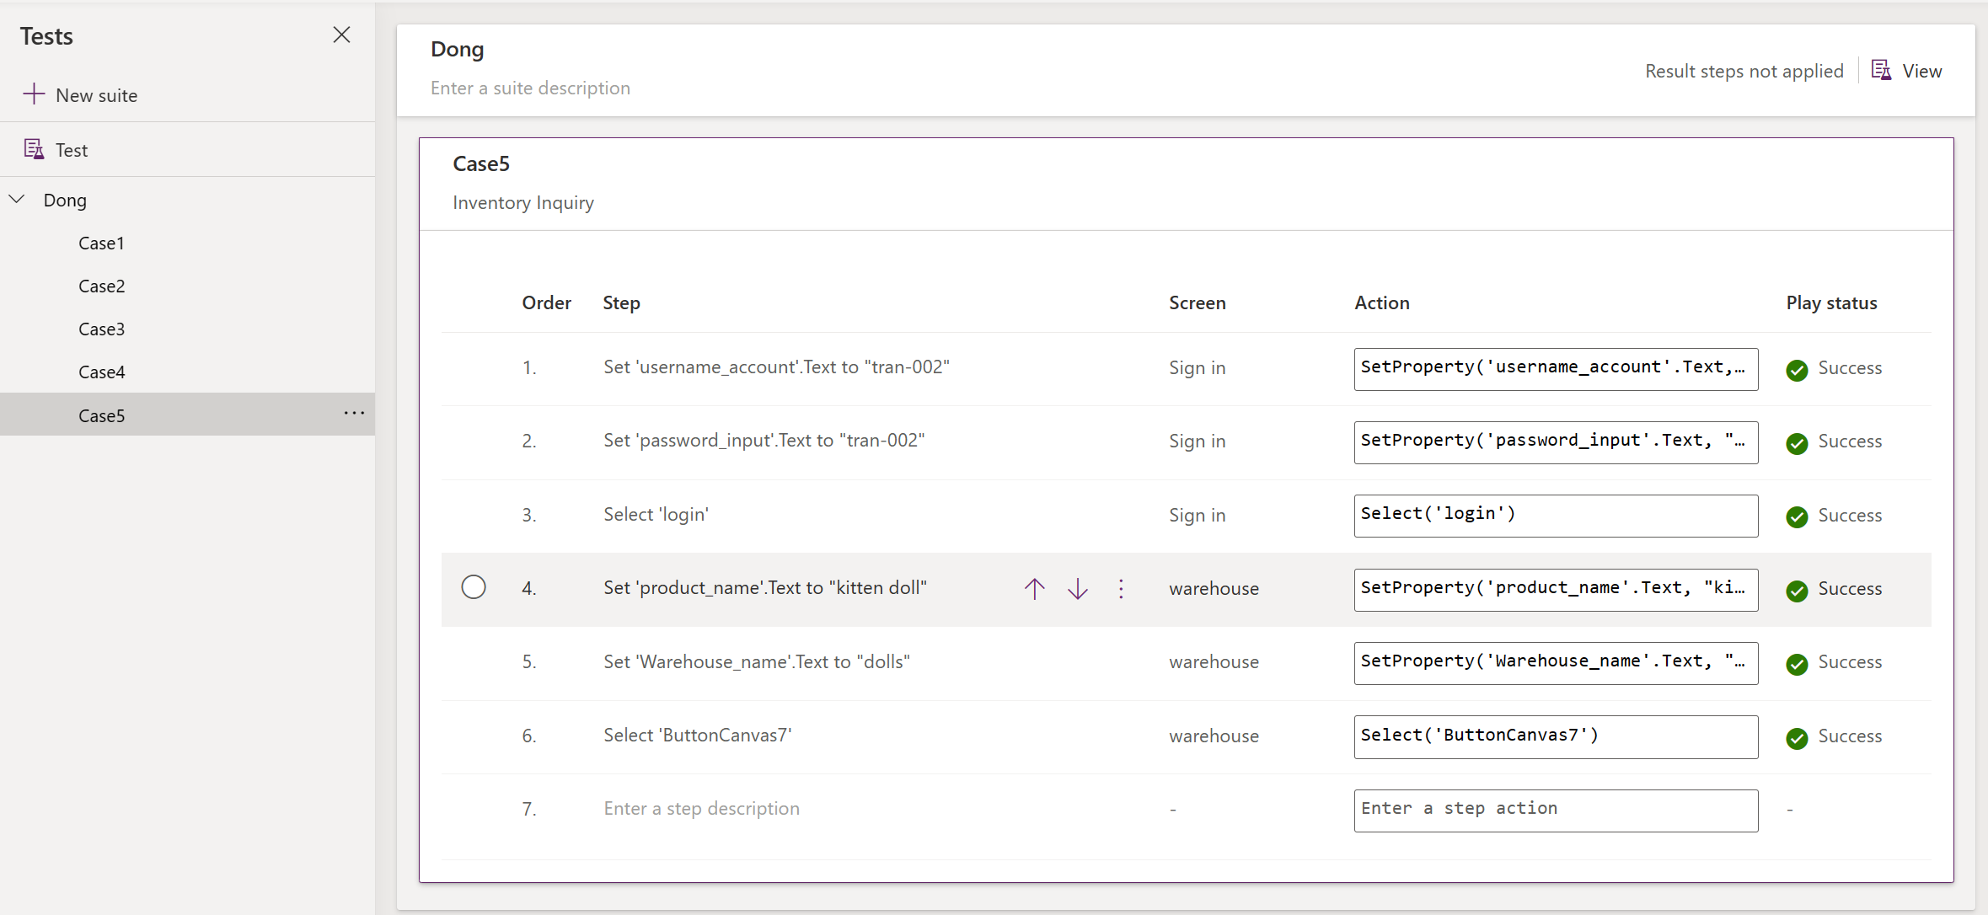

Test case6:

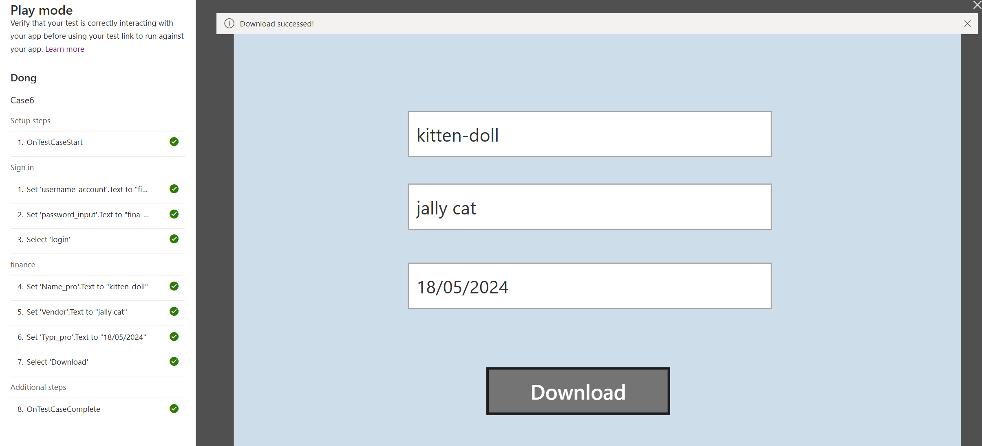

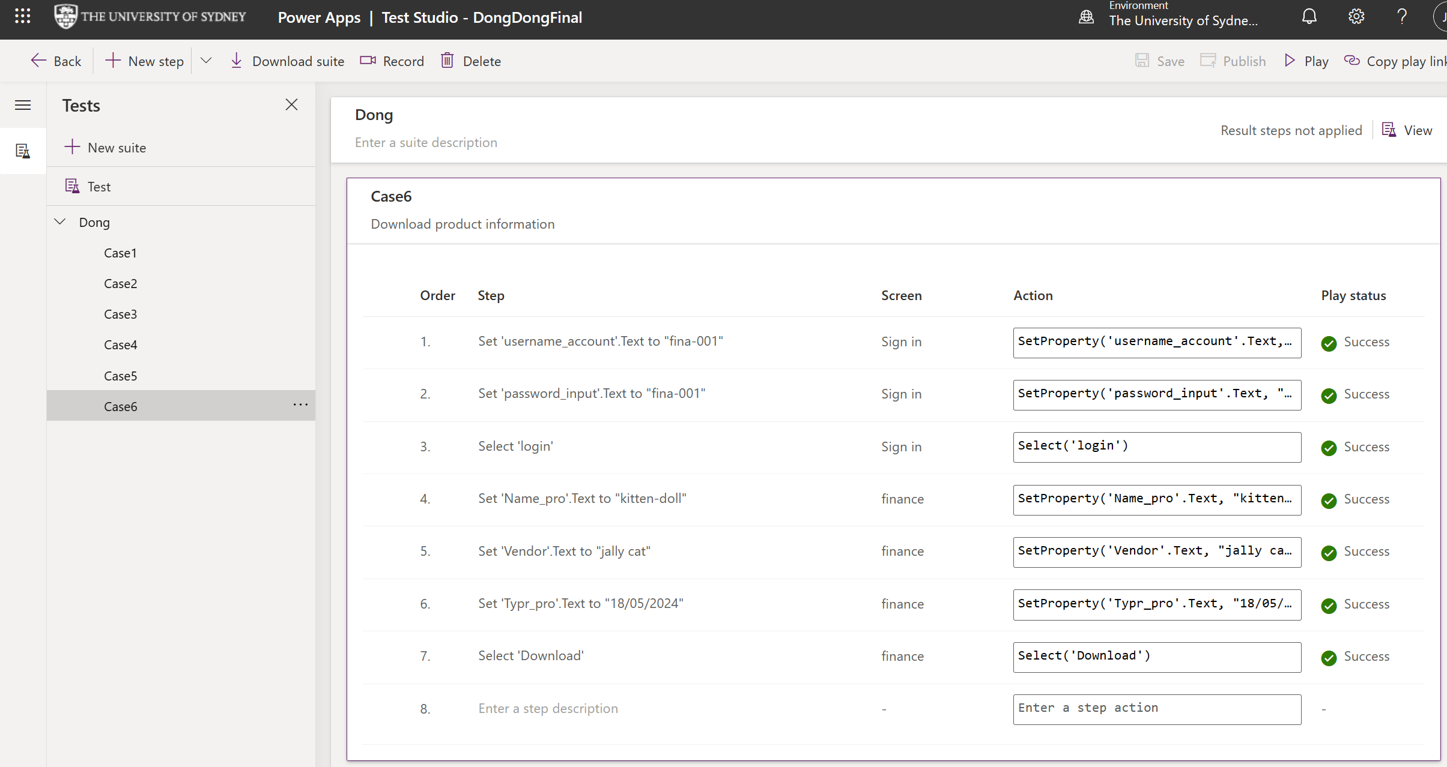

**5. Meeting Log**

#We have a 3-week project, and we have small meeting each week.

Meeting Outline

Week 1:

Time: April 28, 2024, from 3pm to 7pm

Location: Fisher Library

Meeting theme: 1. Discuss how to complete this project. 2. Plan and allocate various tasks for the project.

Host: Kieran Huang

Participants: Haoran Du, Kieran Huang, Chen Yuan, Zhouhan Wang, Jianfeng Zhang, and Jiayuan Zhang

Record: Jianfeng ZHANG

Week 2:

Time: May 12, 2024, from 3pm to 7pm

Location: Fisher Library

Meeting theme: 1. Report progress or submit tasks for each person. 2. Discuss and solve problems encountered during the task completion process.

Host: Kieran Huang

Participants: Haoran Du, Kieran Huang, Chen Yuan, Zhouhan Wang, Jianfeng Zhang, and Jiayuan Zhang

Record: Jianfeng ZHANG

Week 3:

Time: May 19, 2024, from 3pm to 6pm

Location: The Scientific Library

Meeting theme: 1. Integrate all completed tasks and discuss next week's speech. 2. Check the report multiple times to prevent errors.

Host: Kieran Huang

Participants: Haoran Du, Kieran Huang, Chen Yuan, Zhouhan Wang, Jianfeng Zhang, and Jiayuan Zhang

Record: Jianfeng ZHANG

**6. Conclusion**

In conclusion, we have successfully implemented the functions designed in Assignment 1, ensuring error-free operation of our application. We have utilized PowerApps Test Studio for thorough testing of these functions. This report includes a detailed user manual, verification and validation evidence, GitHub records, and Jira reports. Our team has demonstrated effective collaboration throughout the project, as evidenced by our Jira reports and GitHub commit history. The demonstration scheduled for Week 13 will showcase the final application and highlight the advantages and features of our work. We are confident that our application meets the client’s requirements and will prove to be a valuable tool for their operations. We look forward to receiving feedback on our work and making any necessary adjustments to ensure complete client satisfaction.